SHELF LIFE EXTENSION
PRODUCTS FOR FRUITS, VEGETABLES & FLOWERS

KEEP-IT-FRESH

www.keep-it-fresh.com

EXTENDS LIFE

KEEP-IT-FRESH Bags
. . . . E X T E N D S L I F E

Fresh Vegetables and Fruits start to ripen after harvesting and during the ripening process, the fruits and vegetables release ethylene gas. This ethylene gas when in the package increases the ripening rate of the fresh produce hence aggravating the ripening process resulting into faster rotting of the fresh produce. The ethylene gas produced works as a auto catalyst for ripening which in turn produces higher sugar levels causing microbial spoilage of the fruits.

The KEEP-IT-FRESH Bags absorb the harmful ethylene gas produced hence slowing the ripening and rotting process and increasing the shelf life of the packed produce.

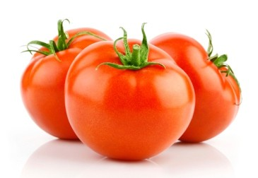

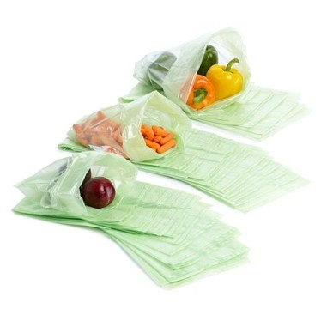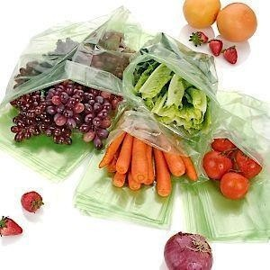Testing on Tomatoes Testing on Bananas
Tomatoes tested for 2 weeks show no spots or fungal growth in KEEP-IT-FRESH Bags compared to start of rotting within 1 week in a plain bag.
The bananas kept in KEEP-IT- FRESH bags aged only by 3 days after actual 10 days when compared to an openly stored banana.

Effective for
Availability

Asparagus, Zucchini, Carrot, Tomato, Celery, Spinach, Lettuce, Oranges, Apples, Bananas, Strawberrries, Grapes, Kiwis, Mangoes, Passion fruits and all kinds of fruits & vegetables
CUSTOM
-SIZES
-SHAPES
-COLOURS
& THICKNESSES

Contact
i n f o @ k e e p - i t - f r e s h . c o m w w w . k e e p - i t - f r e s h . c o m
4X
The film shows
u p t o 4 t i m e s increase in the shelf life of fruits and vegetables under n o r m a l s t o ra g e conditions

